GenAI

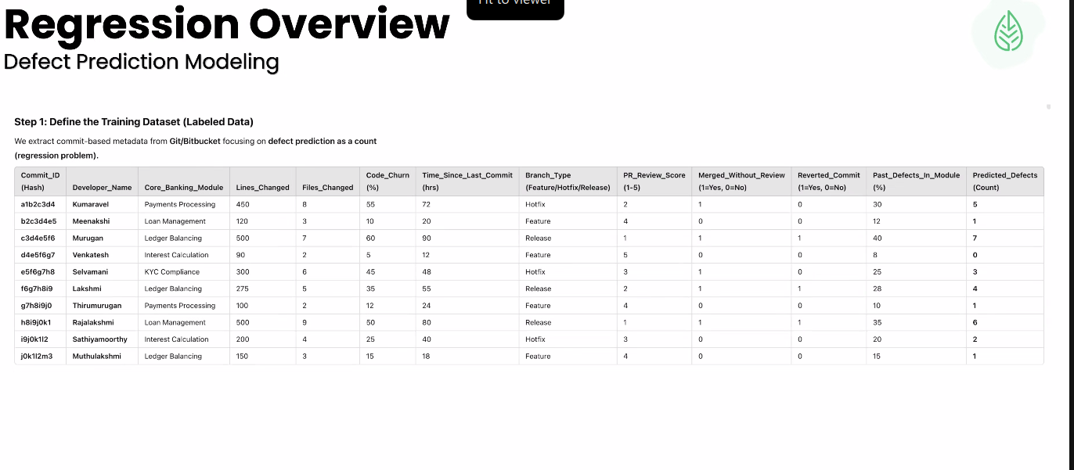

Day2:

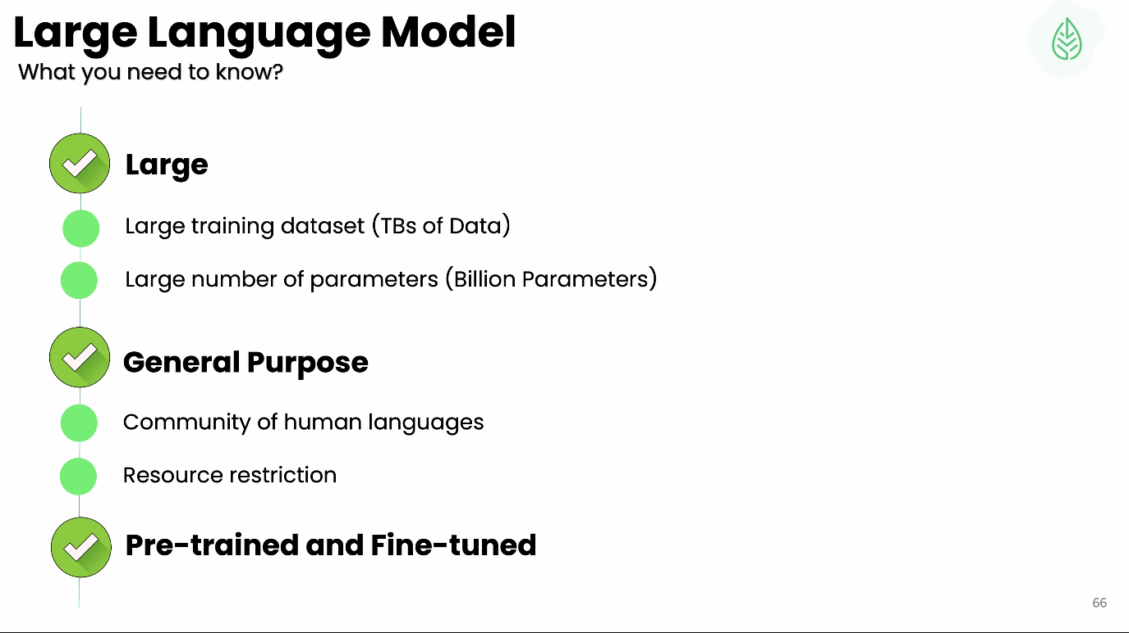

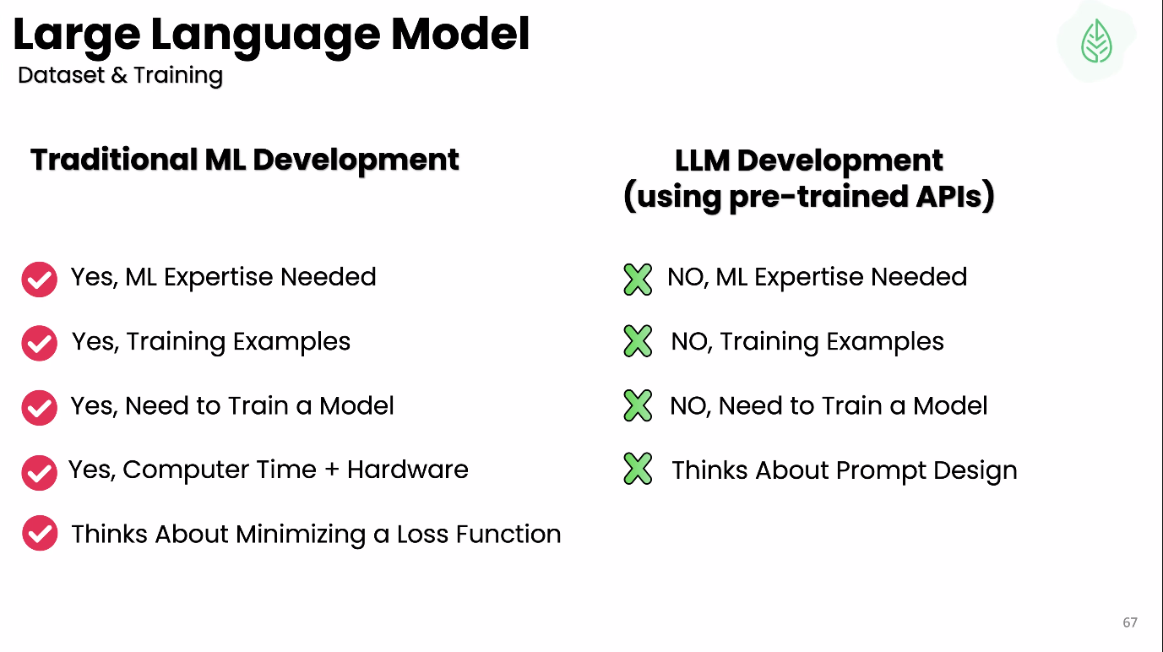

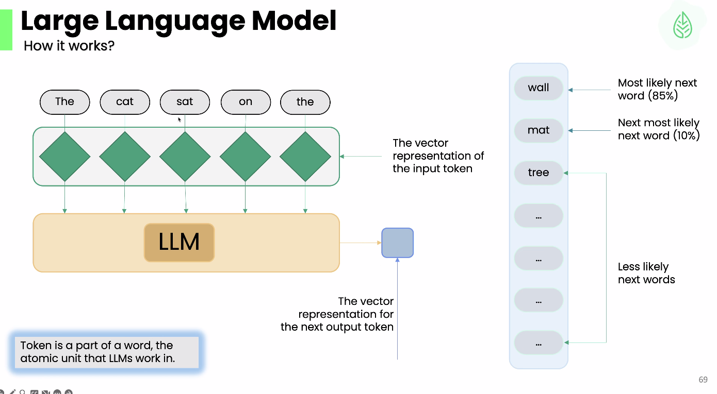

**Step 1: Tokenization**

* The sentence **"The cat sat on the"** is broken down into individual tokens:  
  **The | cat | sat | on | the**
* A **token** is a fundamental unit (a word or sub-word) that LLMs process.

**Step 2: Vector Representation**

* Each token is converted into a **vector representation** (numerical format), depicted by green diamonds in the diagram.
* These vectors capture the meaning and context of the words.

**Step 3: Processing by the LLM**

* The LLM takes these token vectors as input and processes them through its deep learning model to generate a prediction.
* The output is a **vector representation** of the next word.

**Step 4: Predicting the Next Word**

* The model suggests the most probable next word based on statistical probabilities.
* Possible next words and their probabilities:
  + **"wall"** (85%) → Most likely next word
  + **"mat"** (10%) → Next most likely word
  + **"tree"**, etc. → Less likely options
* The model selects the highest probability word to continue the sentence.

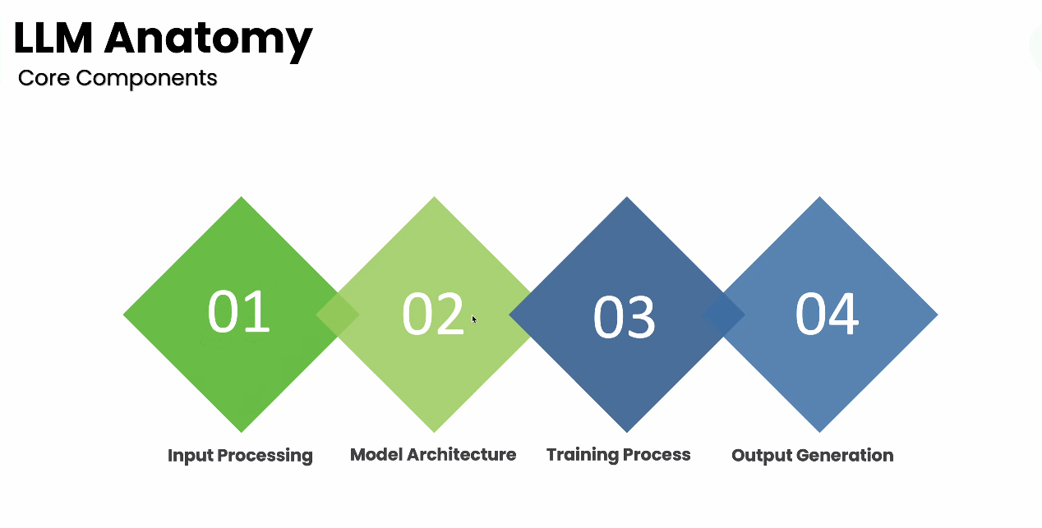

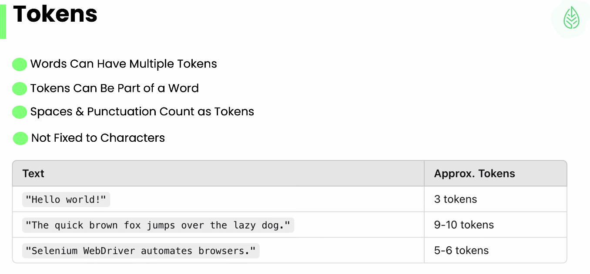

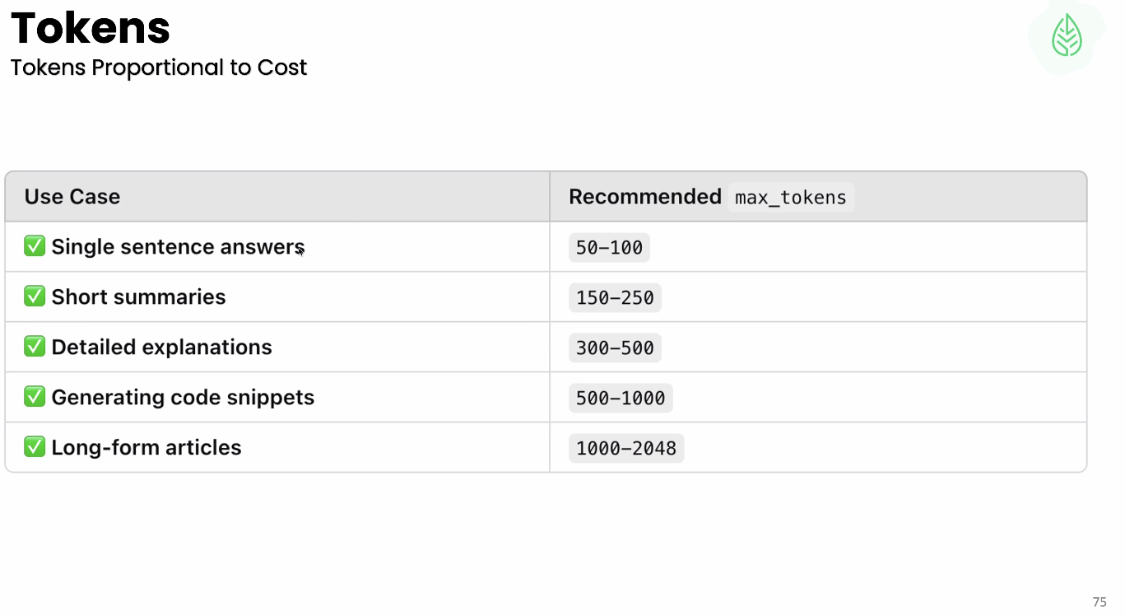

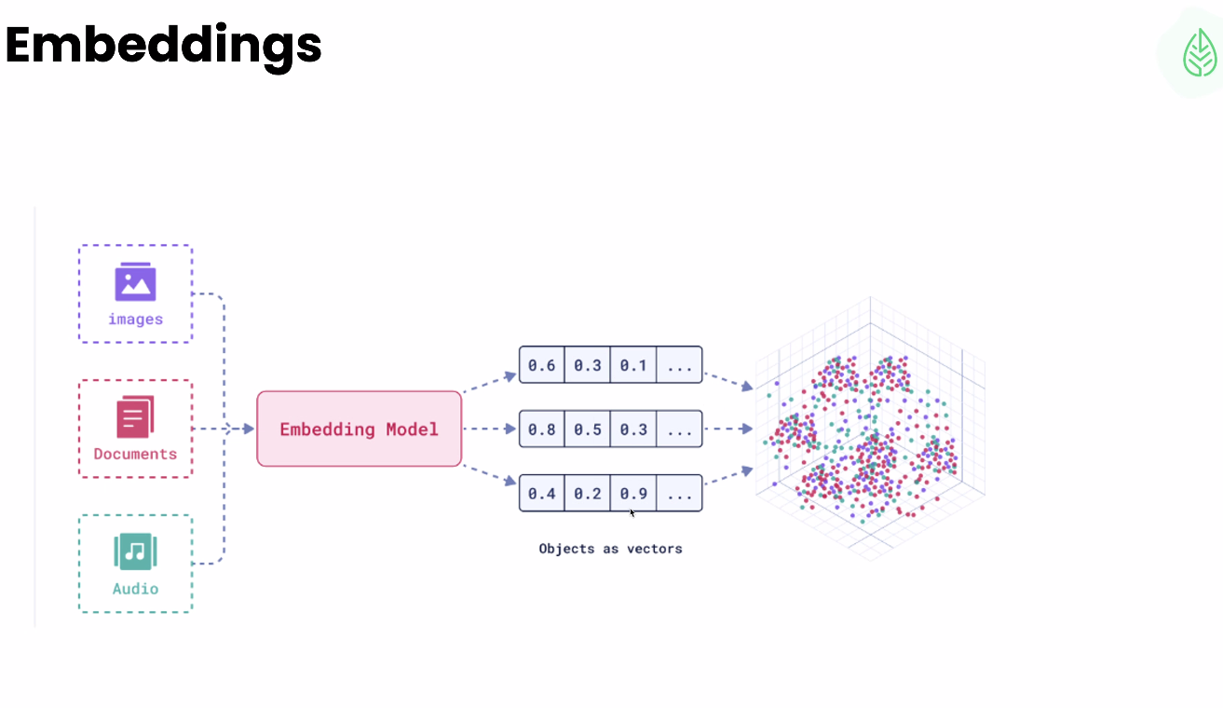

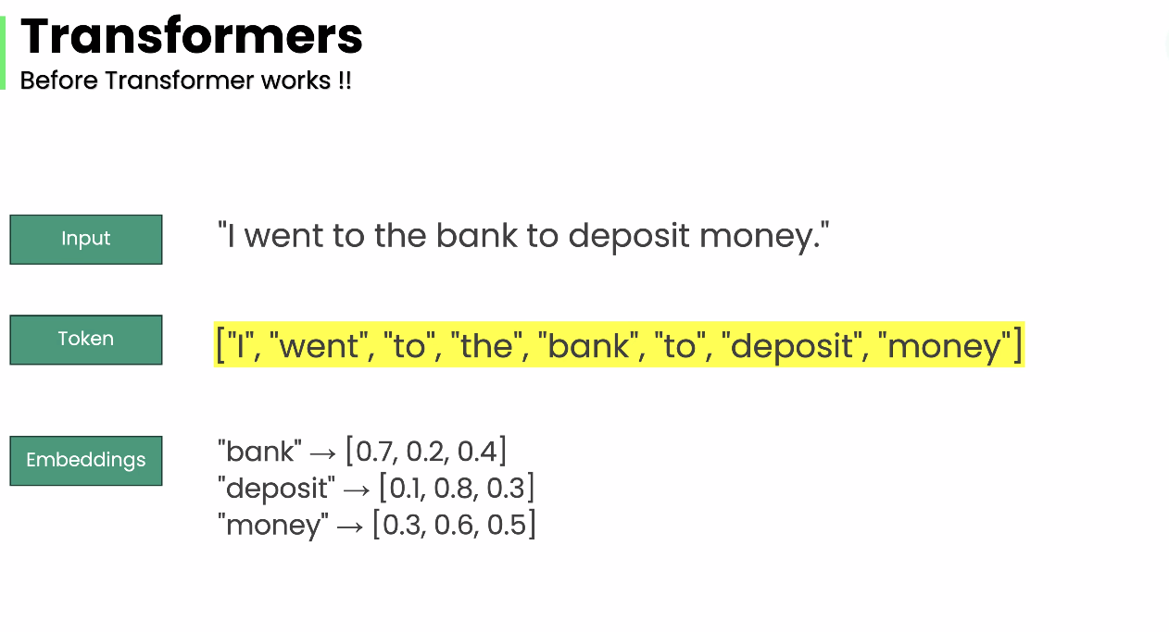

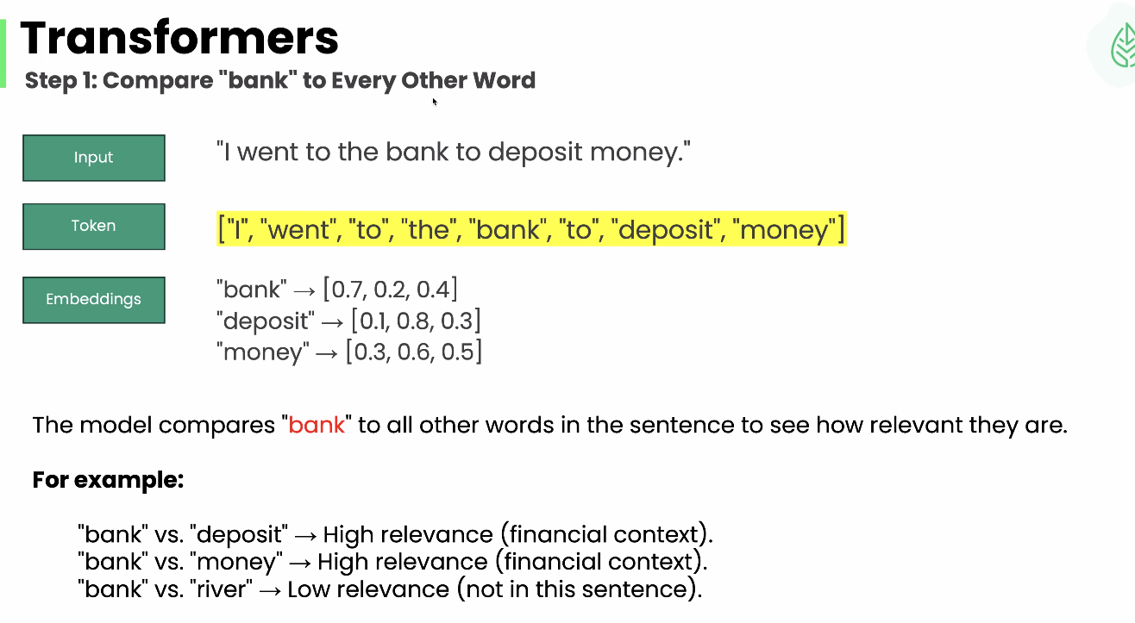

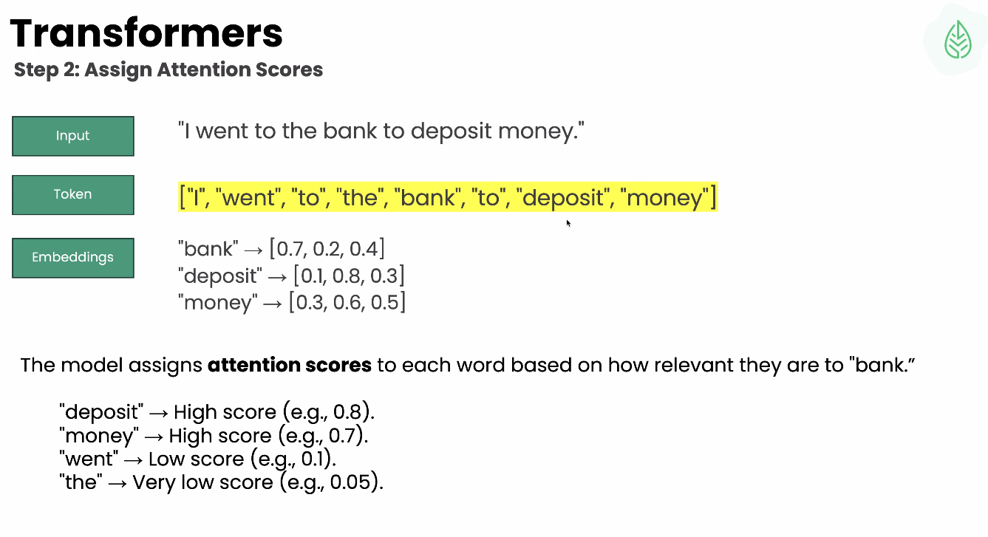

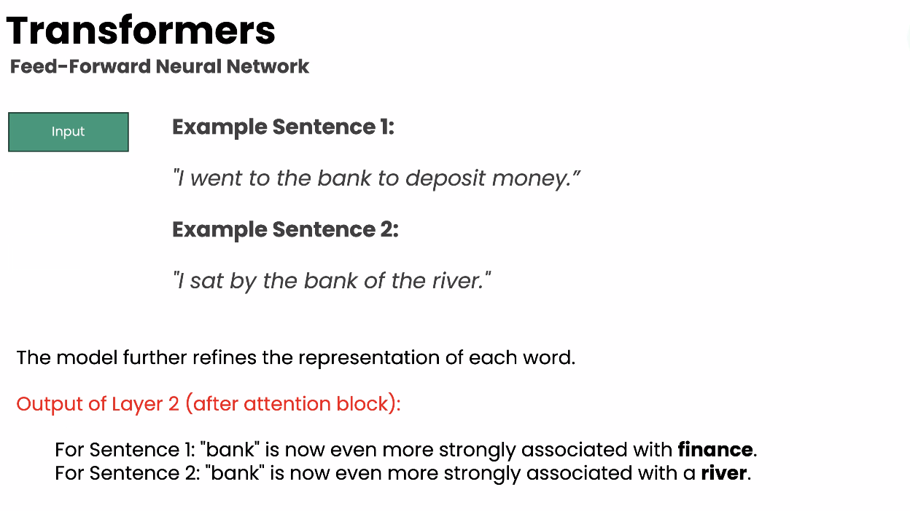

DayD

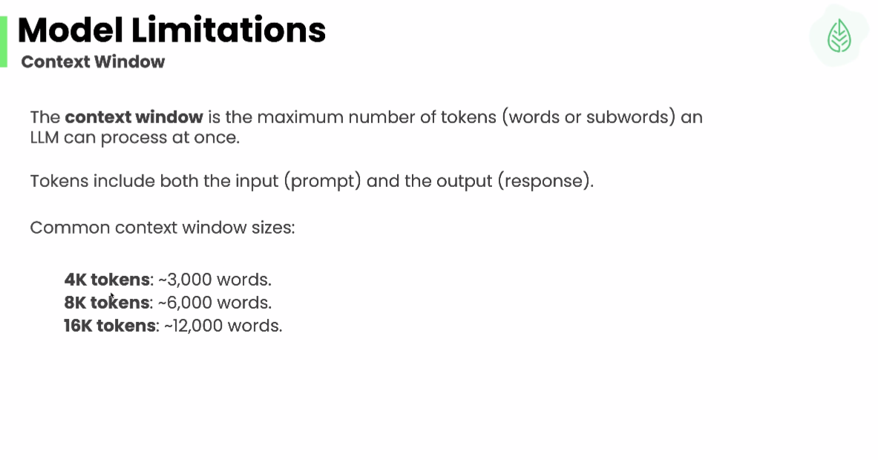

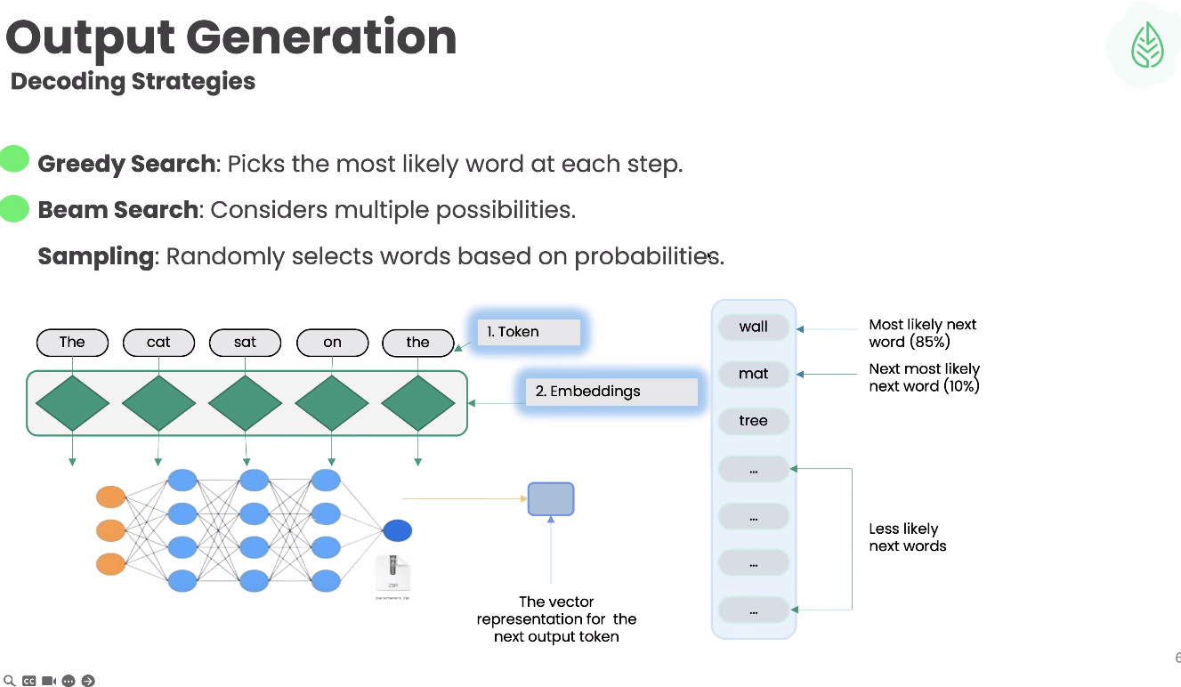

Day3:

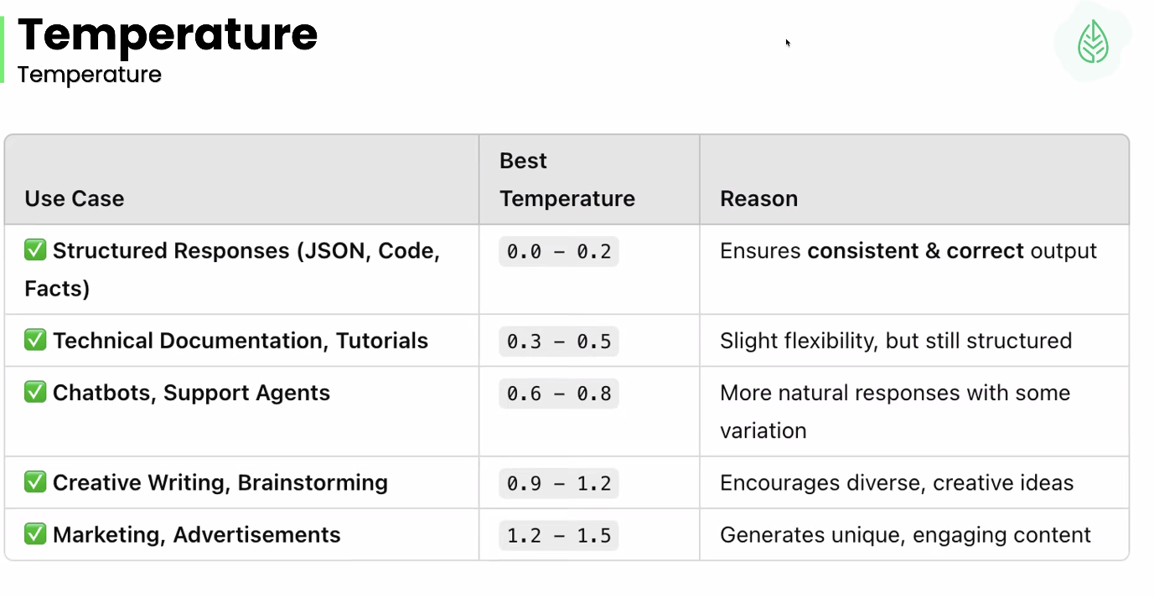

**What Is Temperature?**

* **Temperature** is a number between **0 and 1 (sometimes >1)**.
* It **adjusts the probability distribution** over the next words the model might generate.

**🎯 How It Works:**

* **Lower Temperature (e.g., 0–0.3):**
  + Makes the model more **focused and deterministic**.
  + Picks the most likely next word.
  + ✅ Great for tasks needing accuracy and consistency (e.g., summarization, code generation).
* **Medium Temperature (e.g., 0.7):**
  + Balanced randomness.
  + A mix of creativity and relevance.
  + ✅ Good for general-purpose text generation (e.g., writing emails, explanations).
* **Higher Temperature (e.g., 1.0 or more):**
  + Increases **diversity and creativity**.
  + Words are chosen more randomly.
  + ✅ Useful for creative writing, brainstorming.
  + ❌ Might generate irrelevant or weird outputs.

**📊 Example Prompt:**

**Prompt:** “Write a sentence about a cat.”

* **Temperature 0.2:**  
  *“The cat sat on the windowsill and watched the birds.”*
* **Temperature 0.7:**  
  *“A curious cat climbed up the bookshelf to chase a fly.”*
* **Temperature 1.0:**  
  *“The striped feline orchestrated a jazz concert under the moonlight.”*

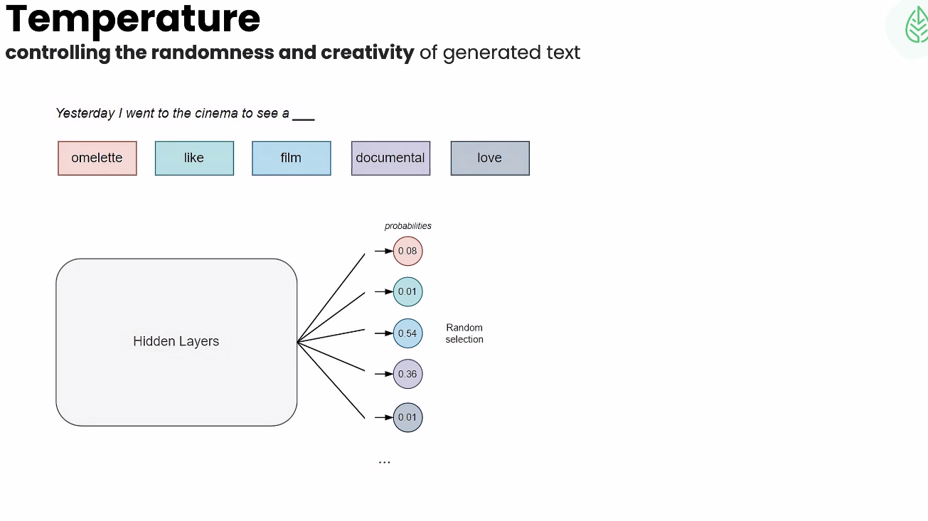

Day 4:

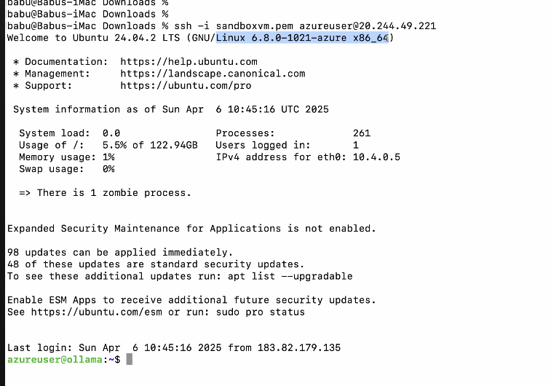

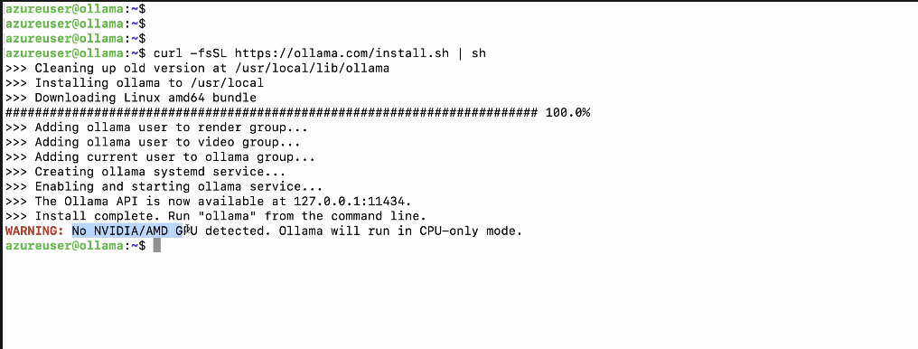

Week 3: day5:

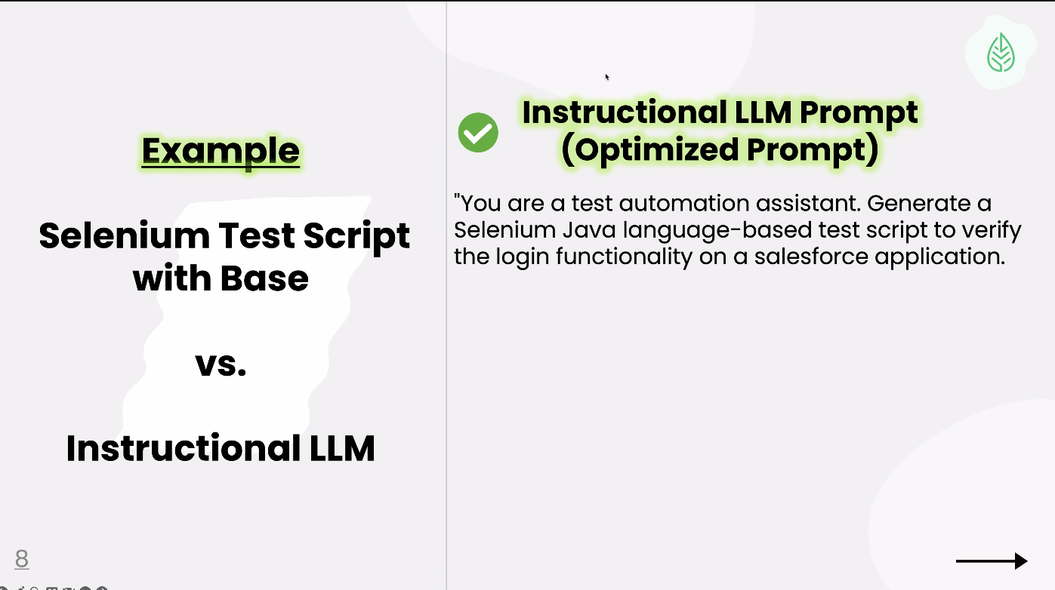

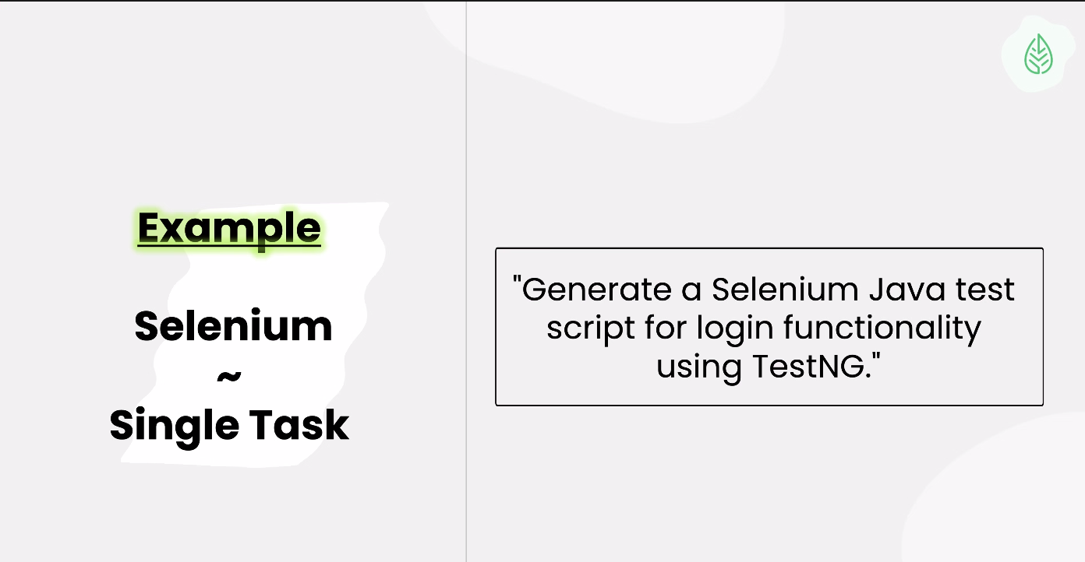

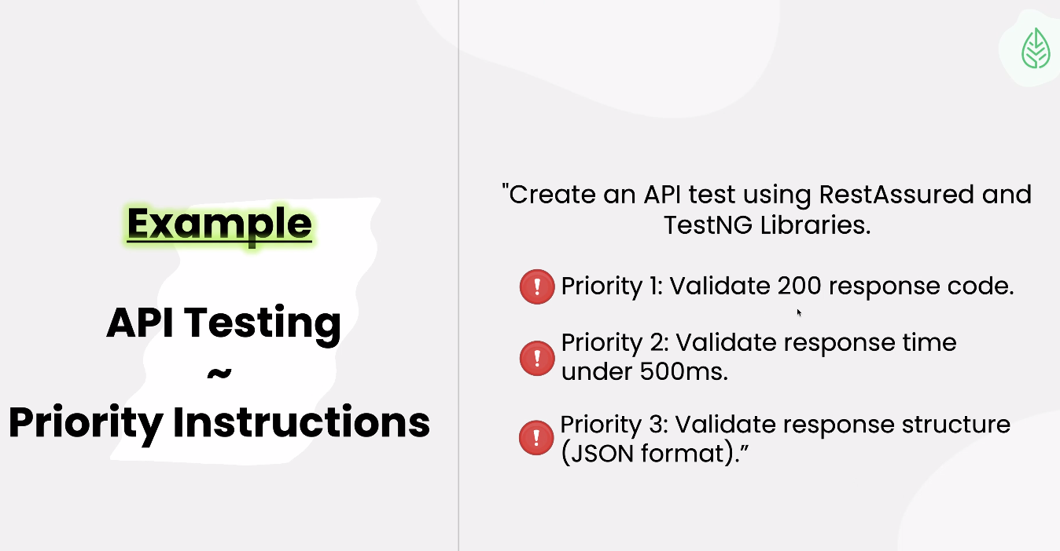

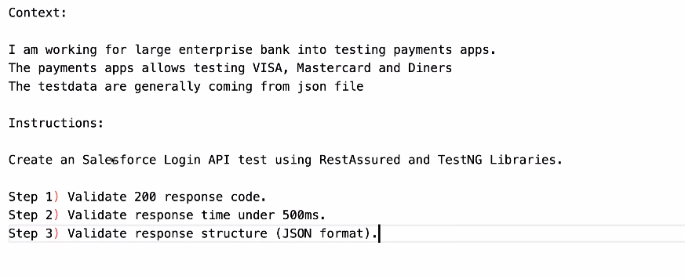

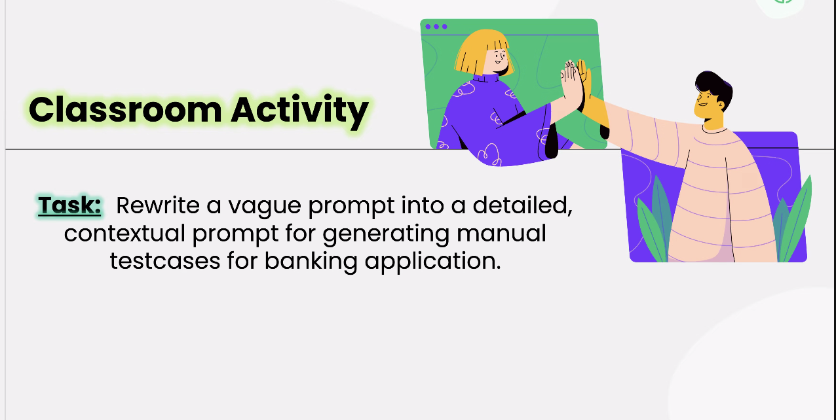

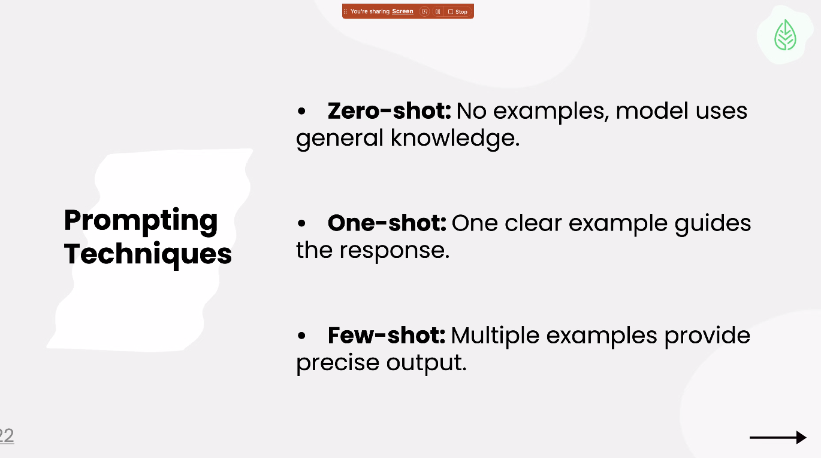

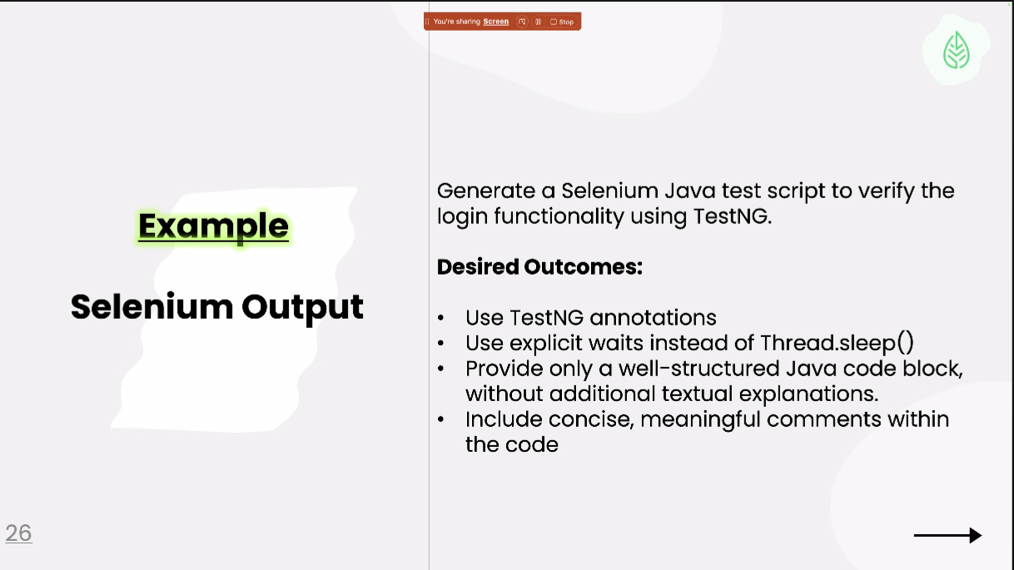

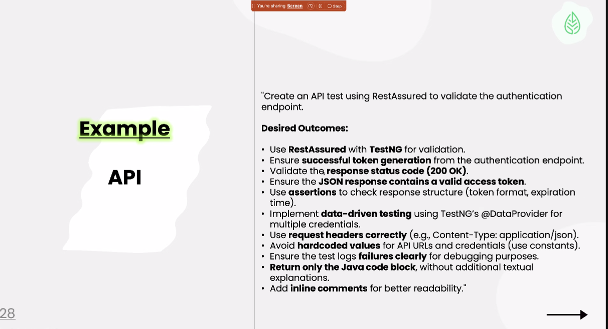

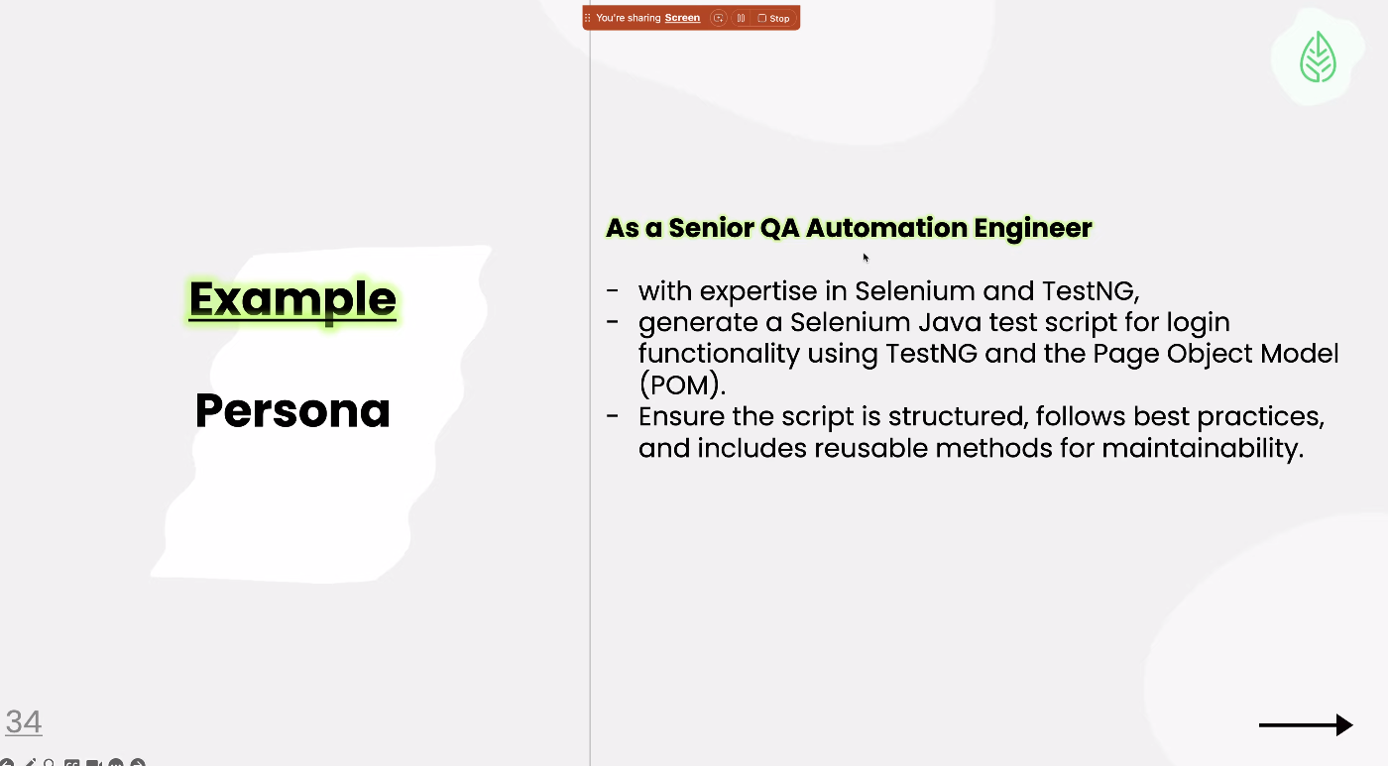

Week 5:

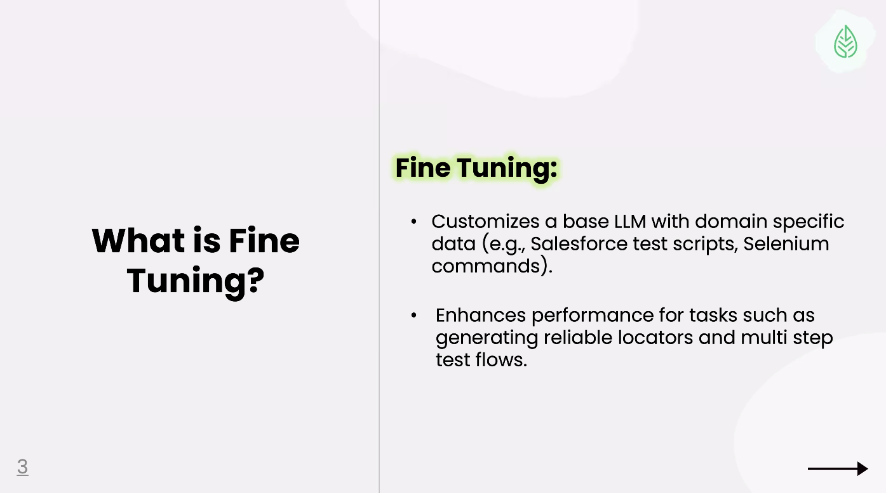

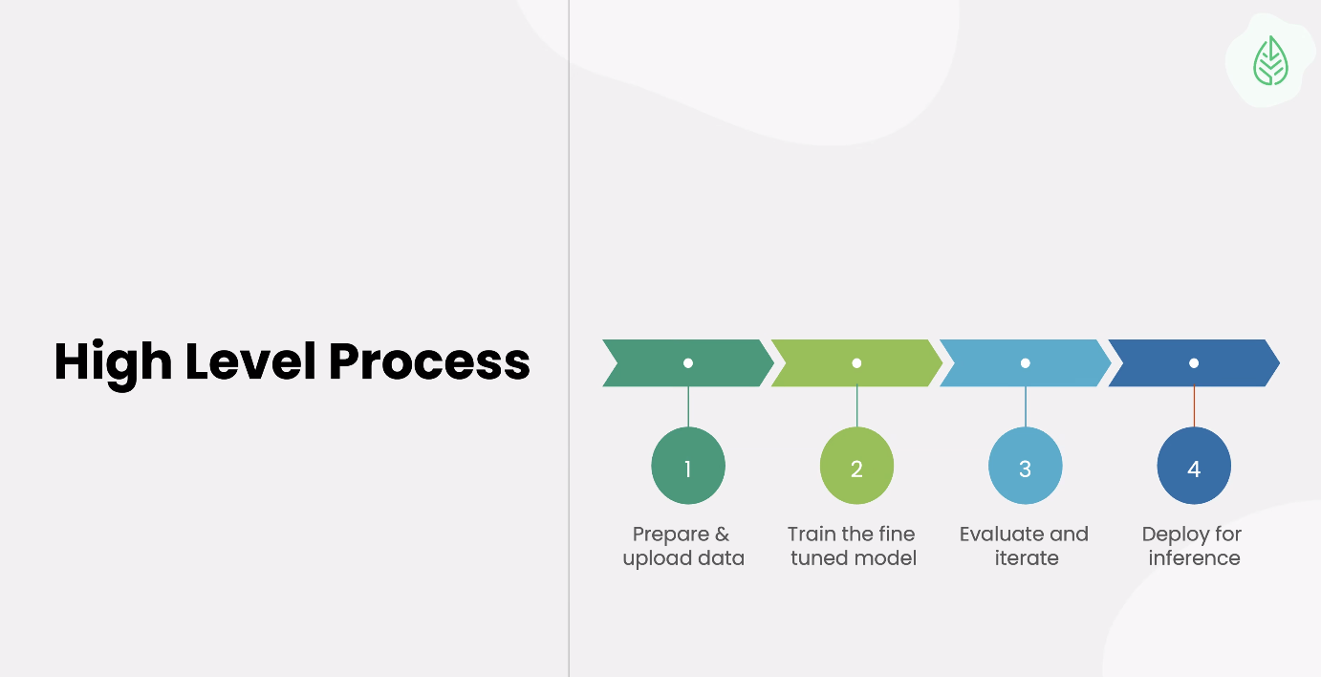

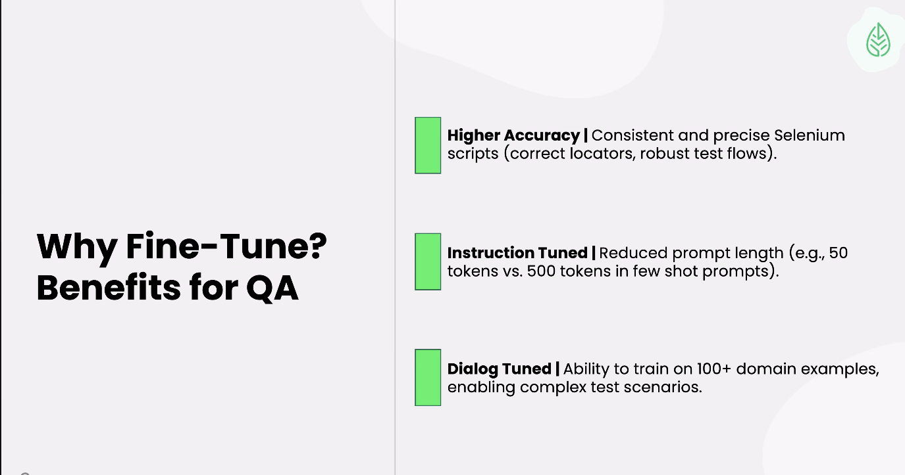

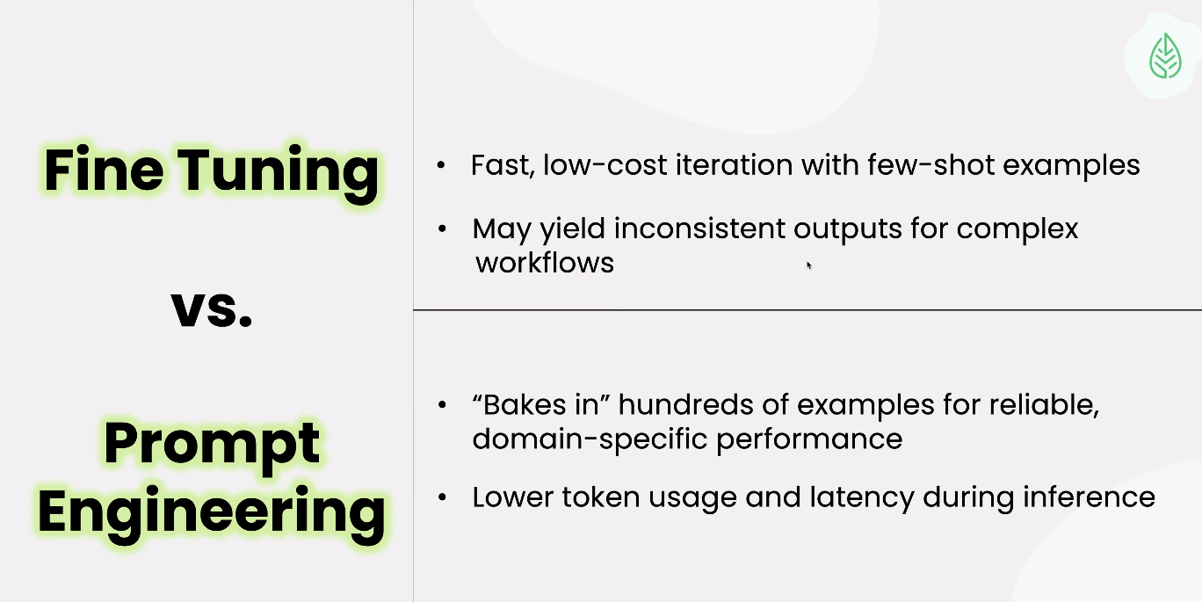

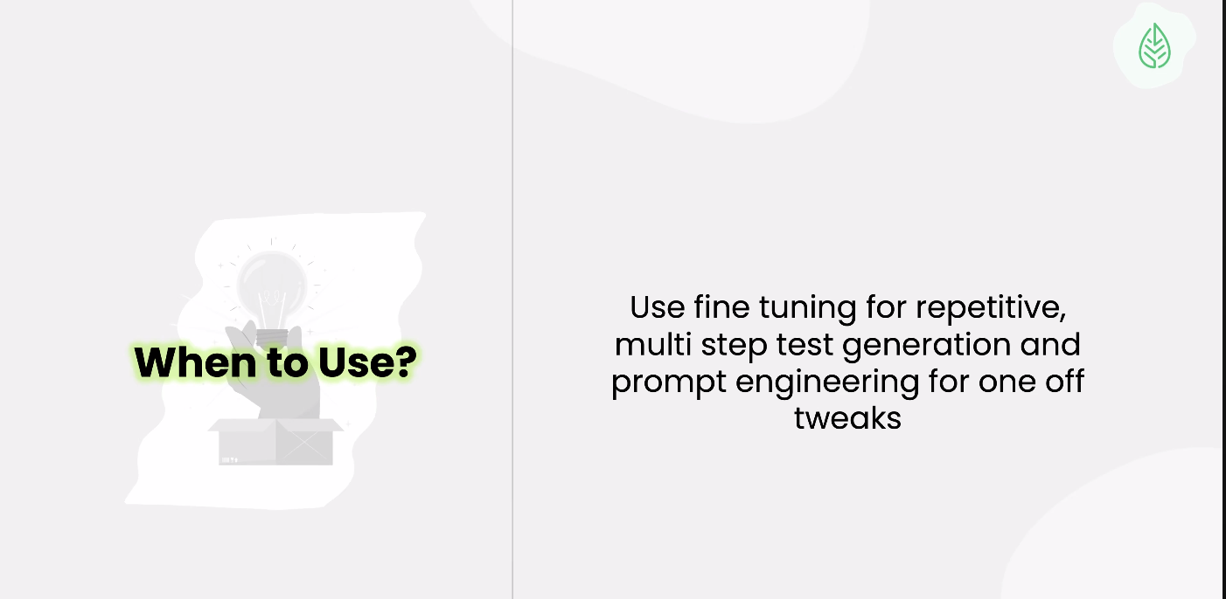

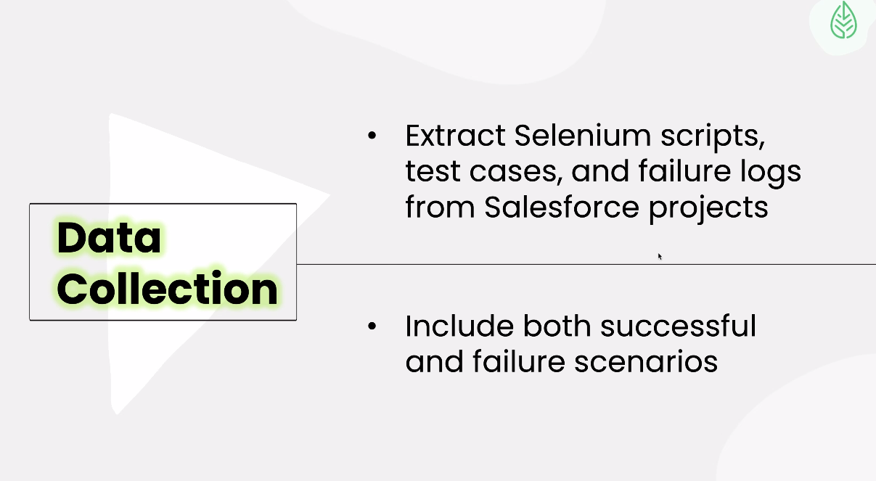

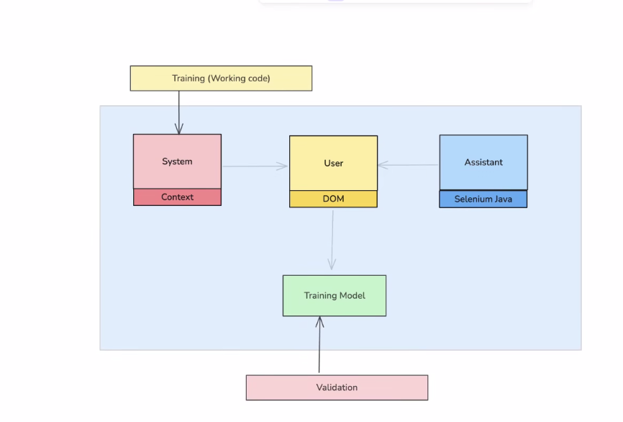

Week5 day2:

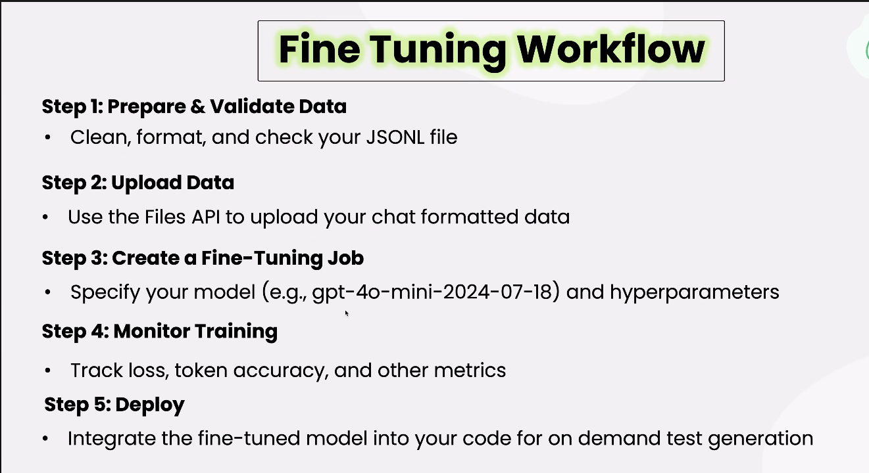

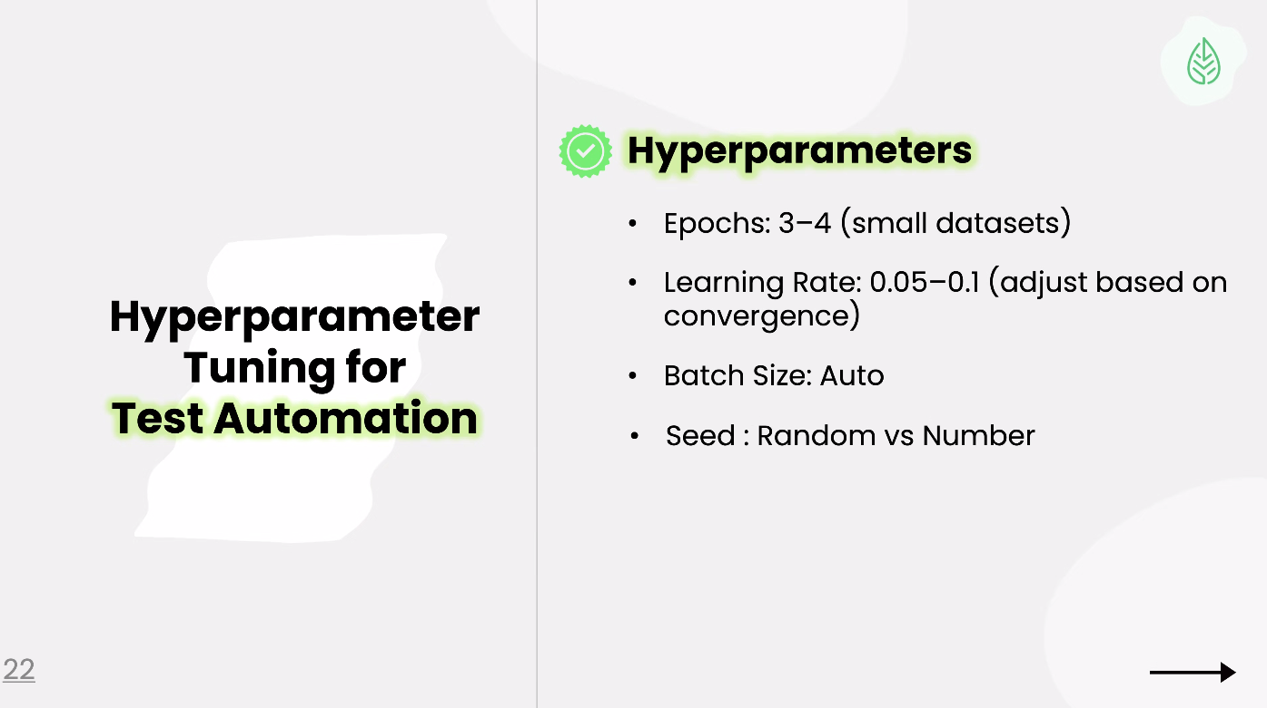

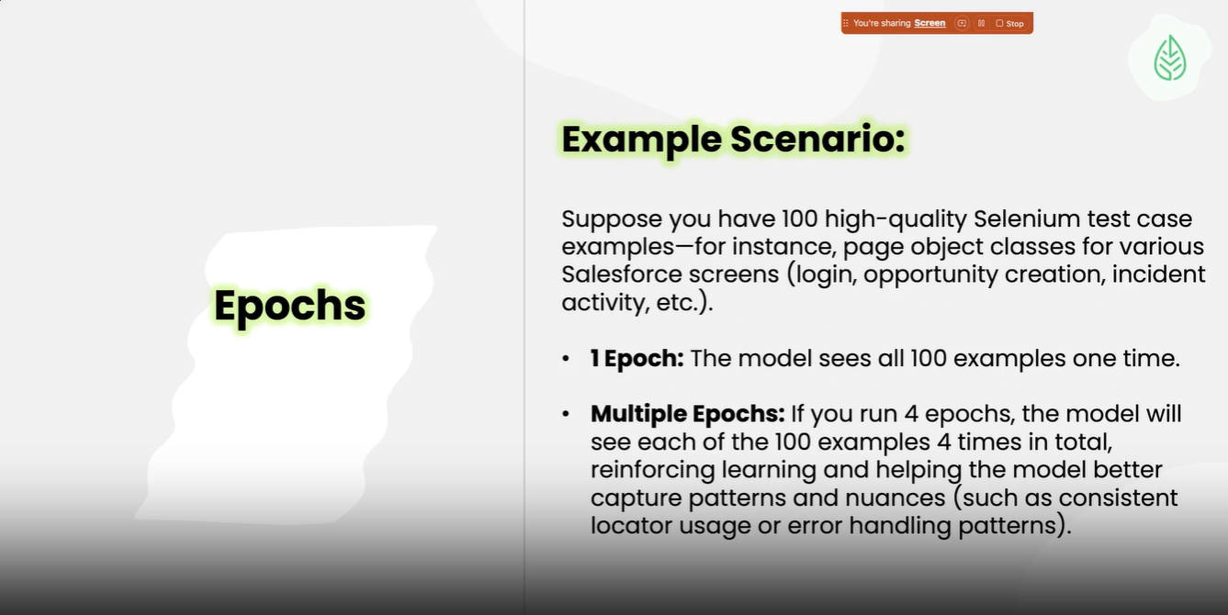

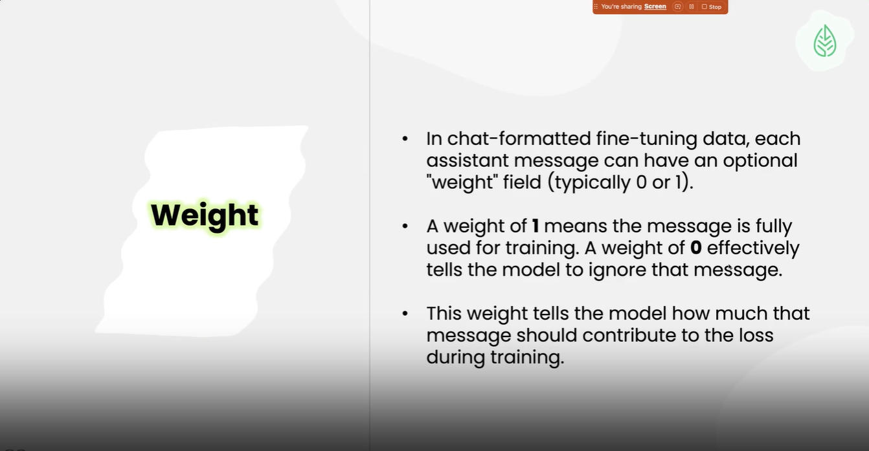

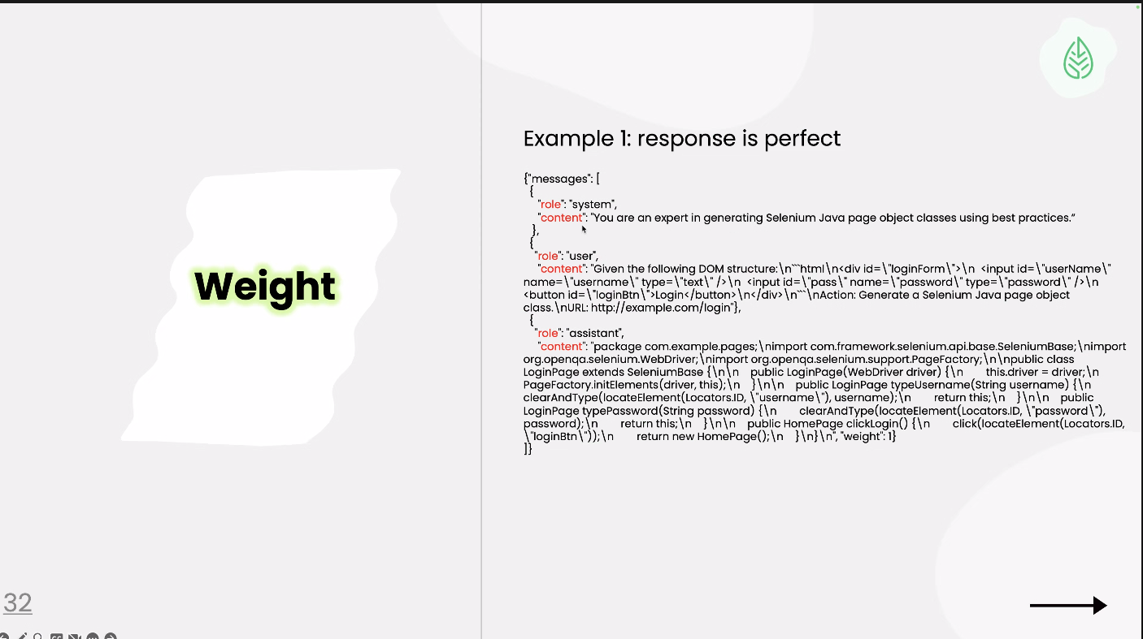

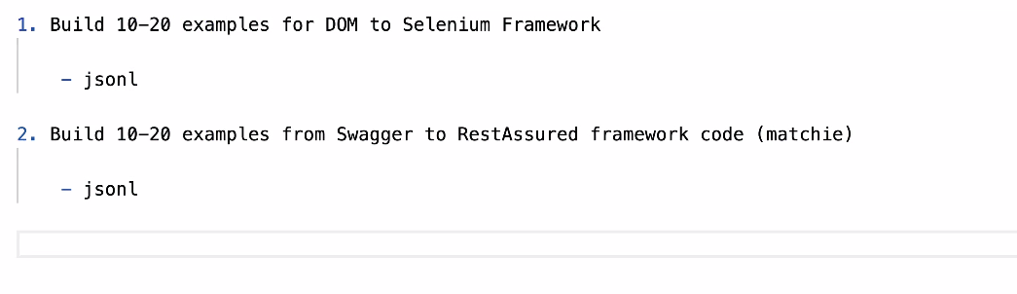

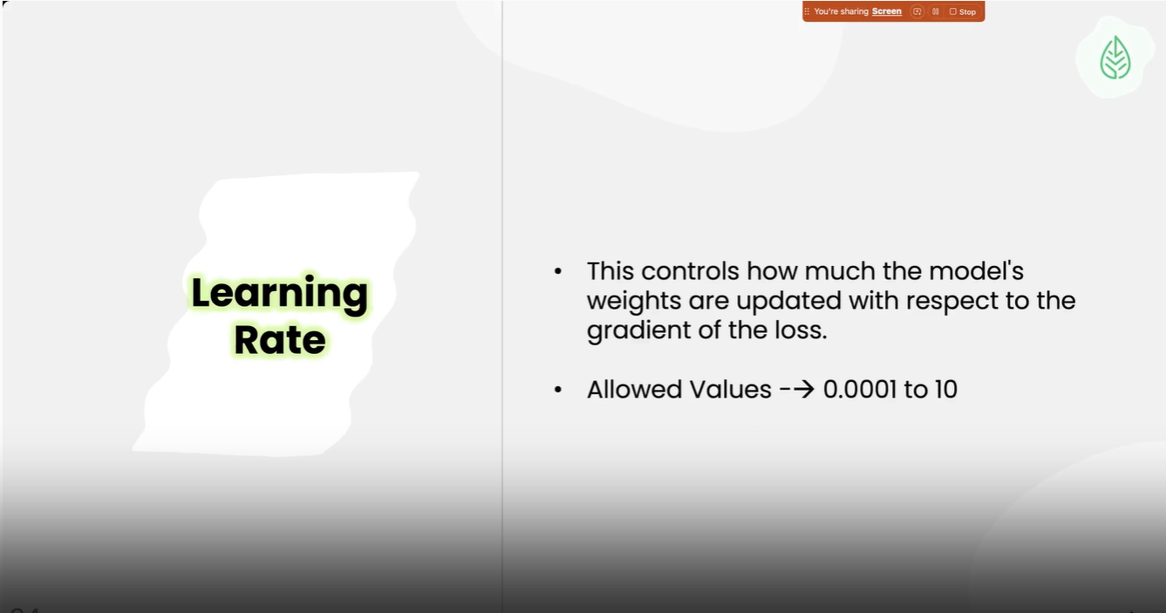

Week 7 Day1:

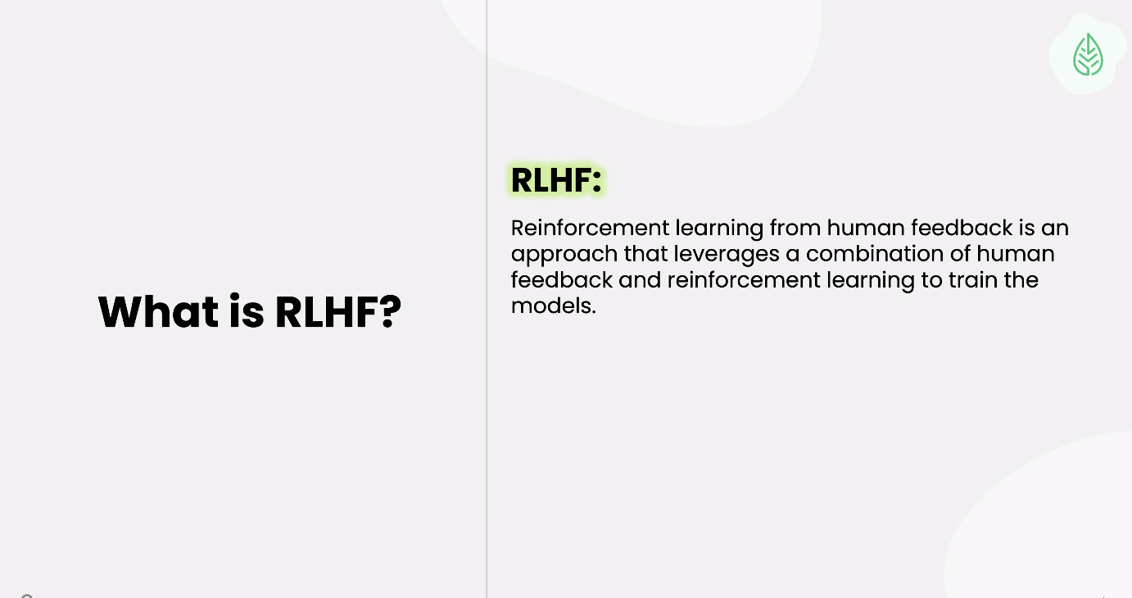

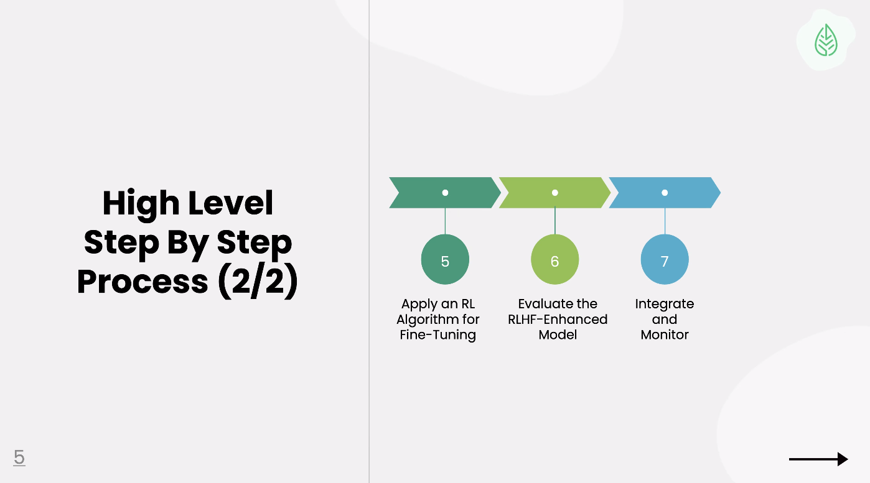

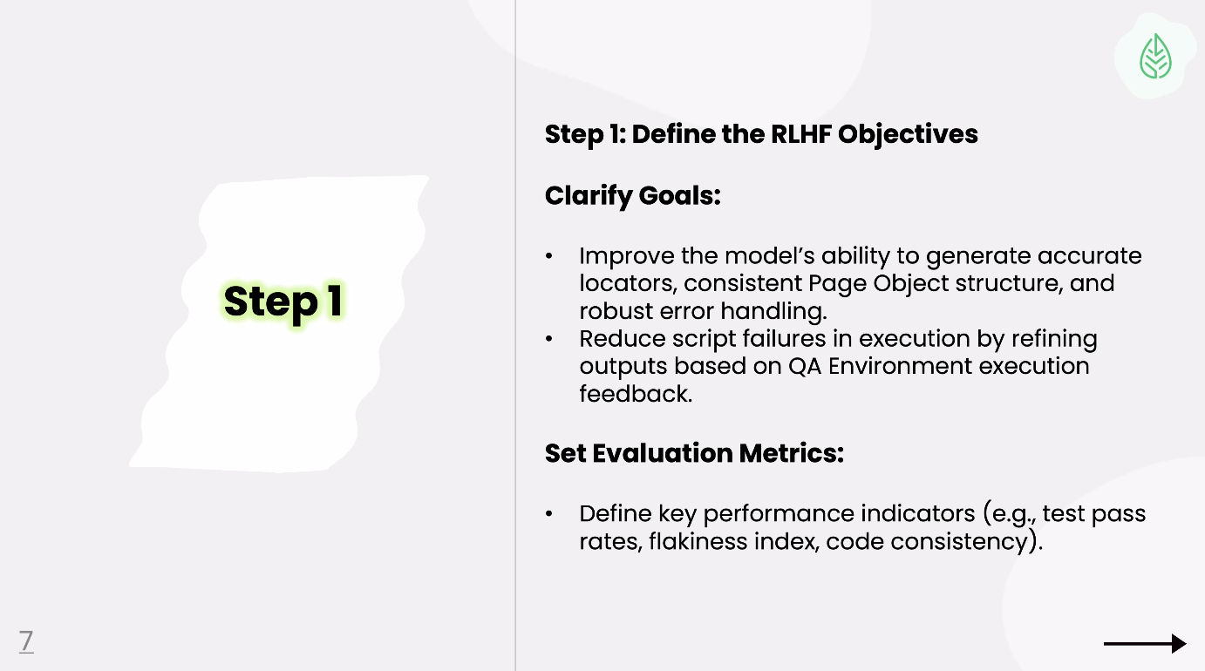

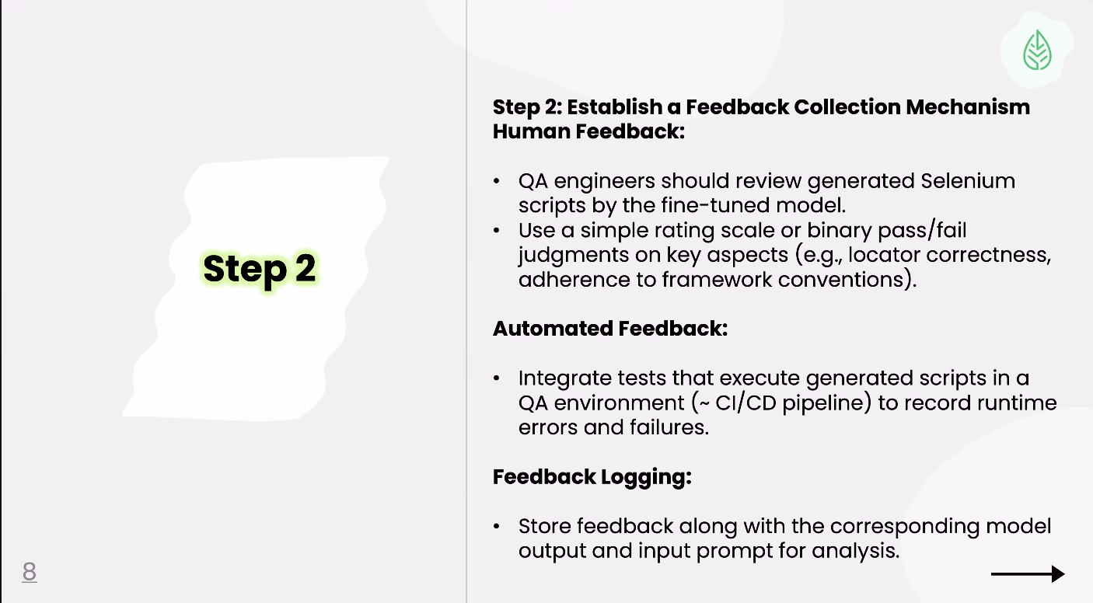

Sample

